September 2015

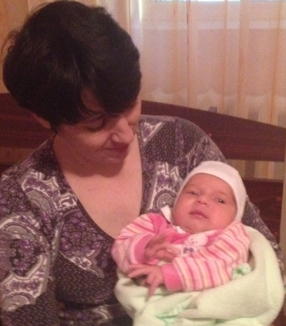
“Children are a heritage from the Lord, and the fruit of the womb is His reward.” 127.3 This is the month of newborn children and of the born again gypsies.

Two families have been blessed by God with newborn child.Kelemen family from Bistrita and Baboi family from Tandarei. Babies are a gift indeed, and a blessing from the Lord.(Baboi Georgiana and her baby girl)

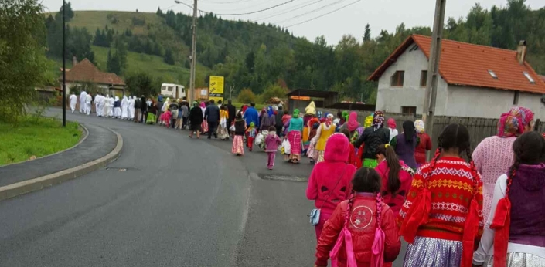
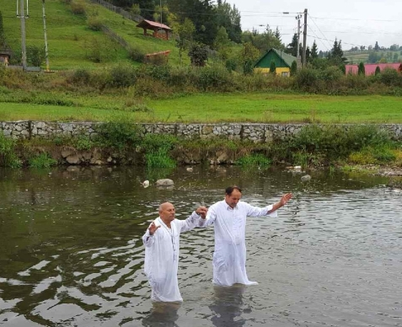
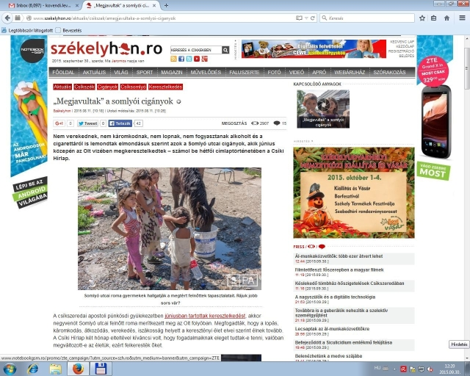
The Gypsy Church of MCiuc has multiplied with 14 spiritual children. New people were baptized by Pastor John in Topliţa on 27th September. The baptism was officiated in the Mures River. Pastor John has new responsibilities. His mission area geographically increased up to 90 km. Being representative
of the Gipsy Party in the county, he is very well received in the Gypsies community. Some pictures about the event. Sorry for the bad quality.
Another very great news about this mission is that after two months of the recent baptism in MCiuc (June ministry letter) some journalists went to see what has changed in that community.
They wrote a very positive article about what they saw and heard. It is a great testimony to the glory of God what these journalists have publicizes on their secular language, about that great change what is seen in the lives of those who areconsidered the lowest in the city. They are still waste pickerswith the lowest income, but they testify of God, who provides everything.Glory to God!
The short version of the newspaper article can be read with Google translate here:http://www.szekelyhon.ro/aktualis/csikszek/amegjavultaka-a-somlyoi-ciganyok
It was a joy to visit thefamilies of two volunteers, Baboi Marian andDanţuşIulian.
We spent blessed hours together. We had the opportunity to share our experiences and ask God's blessing on the prison ministryand on our families. On this occasion I could transport 2,400 Christian books for inmates of 6 Prisons. Brother Baboi attended an extraordinary meeting with the prison management in Braila. Here isthe picture.
ViorelSintoiu has also attended a meeting in Codlea Prison. He otherwise informs you in a separate letter about his work.
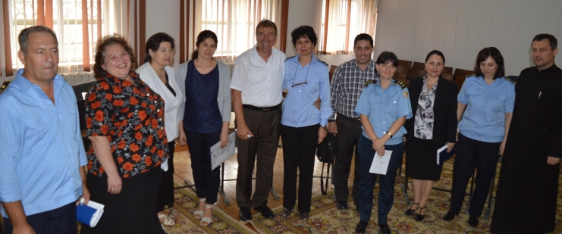
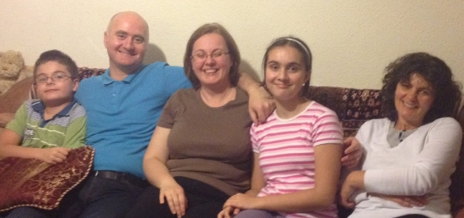
Another good achievement by grace of God that we supported Codlea and MiercureaCiuc Prison classrooms with necessary materials. The managements of the two prisons transmit to you all their best wishes and a humble thank you. Praise the Lord for every good gift!

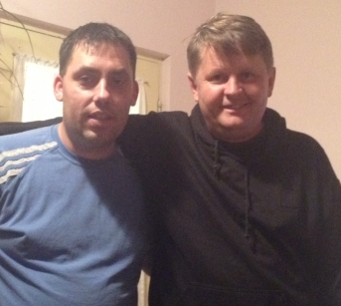
Starting from September we work with long-term program Mciuc Prison. We received a group of 16 inmates, and they manifest deep interest for the Word of God.
DincaNastase is hospitalized again with heart problems. His condition is serious.
We pray that God will have mercy on him these days.

May God bless you for investing in prison ministry here in Romania!

With love in Christ

