October 2015
So when this corruptible shall have put on incorruption, and this mortal shall have put on immortality, then shall be brought to pass the saying that is written, Death is swallowed up in victory.
O death, where is thy sting? O grave, where is thy victory? 1 Cor.15,54-55

Brother NastaseDincă,retired police officer went hometo the LordonOctober 7 after a long illness.
We workedtogethertwo years.He was aworthyvolunteerin the prison ministry.The Lord usedhim to lead many to the knowledge of God.ViorelSintoiurepresentedour organization on the military-style honorsfuneral. He preachedthe wordof God as one of his closest friend.
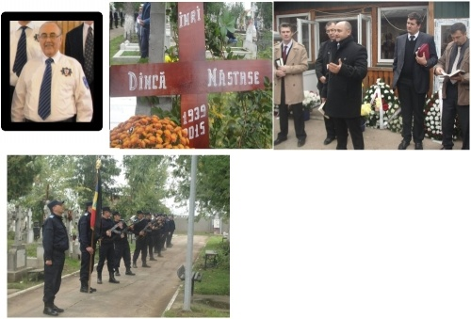
We give thanks toGod forthese years.Thank you for praying for him when he were in terrible sufferings, the Lord had mercy onhim.
Thankyouthehelp of many of youwhopraywithus, shareyourfinances. May Godblessyouall!
The Biblestudygroupsmeetweeklyint he prisons. Ourvolunteersdo a blessedministrybygrace of GodAlmighty.

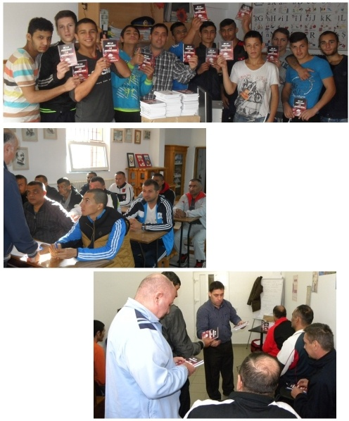
Wealreadymanaged todistributeabout approximately2,000bookstoprisoners. It is a book of atestimonywrittenbya formerprisoner,designedespeciallyforprisoners, quality Christian literature.
Please pray that may God use this book for every inmate who will read it. Here are somepicturesaboutaction.

We managedto get tohis brotherViorelSintoiuthis month. BrotherJohnjoined us this time.
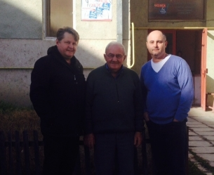

With love in Christ

