April 2023
Prison
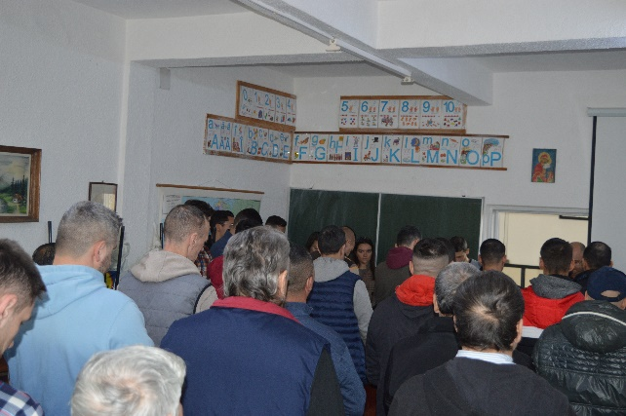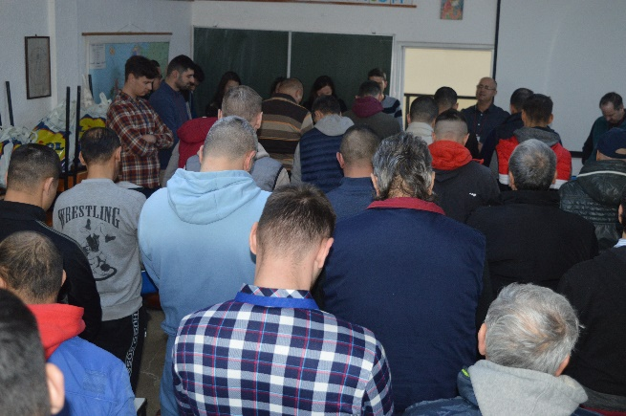
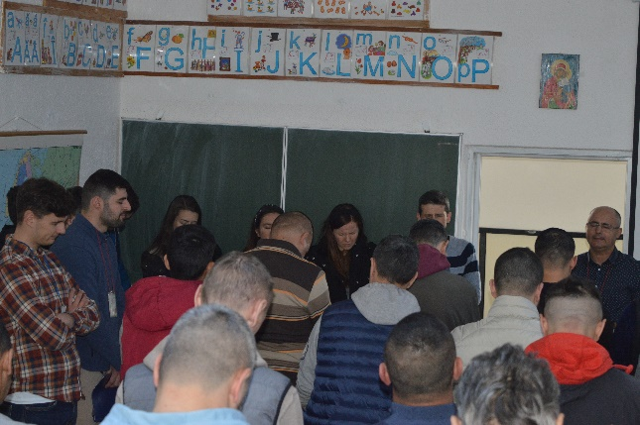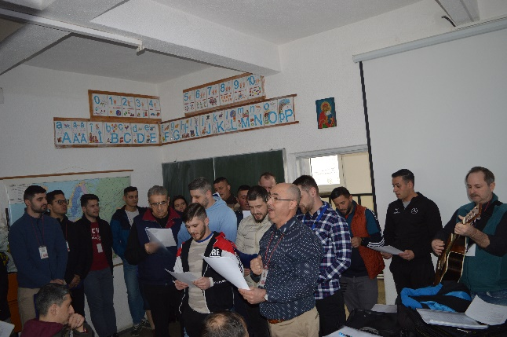
We had several special events in the Penitentiary in April.
The halls of the Penitentiary in Codlea resounded with songs
I learned 4 songs with the current group and for the first time a song in English, "I sing praises to your Name, oh Lord." "
I completed the course with the current group after about 4 months
I organized an evangelization together with a group of young people from Brasov
I bought 50 packages of sweets for the prisoners
We offered Bibles, we offered the book "God loves you", correspondence courses, daily meditations, diplomas.
The message was a special one brought by a former drug addict, but who has now repented.
The classroom was an archipelago. We prayed together and several of them prayed with me.
The general message was: "I'm sorry that the course is over." I would like to come even without receiving credits, I learned a lot of basic things that I didn't know."

April 2023
3474 lei
Levi table 2500 lei
Charity and 6 inmates 974 lei .

Thank you for your support.
Be blessed!
Viorel Sintoiu, Covasna.
May 4, 2023

