April 2024

prison

Completion of the course, Easter celebration.

A day full of the presence of the Holy Spirit. Our songs resounded in the corridors of the Penitentiary. The message preached by Pastor Angel touched the hearts of the inmates. We prayed together. I prepared diplomas for the 11 inmates who completed the course. We offered Bibles to those who requested. I prepared a package of sweets for all the inmates present. We prayed together and several inmates opened their hearts to the Lord Jesus.

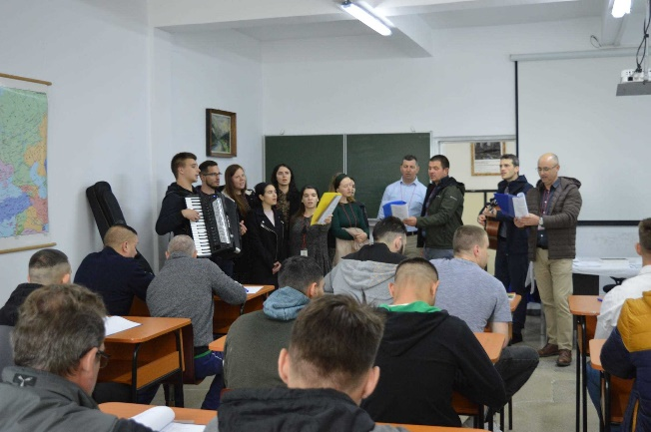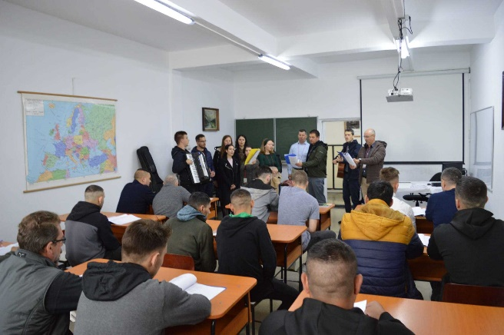

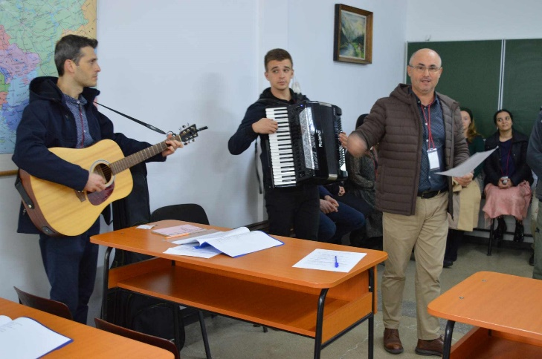

4 inmates helped in April as well

Invitation to Codlea

Meeting together with the management of the Penitentiary and the representatives of the Institutions from Brasov county. Various problems within the Penitentiary were discussed, as well as prevention solutions. Drug use and violence have increased in Brasov county, from the youngest ages.

April, Berean 4462 ; Levi 3270, charity 1192 .

Thank you very much for all your help.

Be blessed!

Viorel, Covasna